**Unit –v**

**Sizing the drive system:**

Matching the electric machine and the internal combustion engine (ICE),

Sizing the propulsion motor,

Sizing the power electronics,

Selecting the energy storage technology

**Introduction to Hybrid Vehicle Design:**

The design of Hybrid vehicle have following requirements are

**1.** Power and Mass Computations for Initial Vehicle Sizing

**2.** Power Requirements

**3.** Acceleration Power

**4.** Grade-Climbing Power

**5.** Vehicle Mass

**6.** Component Sizing

**POWER AND MASS COMPUTATIONS FOR INITIAL VEHICLE SIZING:**

 Hybrid electric vehicles (HEVs) are expected to meet two performance criteria in order to compete successfully with conventional vehicles. 

 The first criterion is the time required to accelerate from zero to 60 mph. 

 The second criterions is vehicles must also be able to negotiate a minimum grade at a constant speed. 

 Argonne developed a model to compute power requirements associated with these criteria. 

 Each drivetrain component is sized to meet the power requirements and its mass is then computed  

POWER REQUIREMENTS

 

 The procedure presented here estimates power requirements for accelerating on a flat road (no grade) and negotiating a grade represented by an angle θ at a constant speed. 

 We assume that the air is still and vehicles are not required to accelerate from a stop to the maximum speed up a hill or a ramp.  

**ACCELERATION POWER:**

 A hybrid vehicle that has an inertia mass of *Mv* and is accelerating on a flat road (i.e., 0° grade) would require a power *Pa* specified by the following equation. 

 The above power equation is at the wheels. After the acceleration power is determined, the drivetrain components would be sized to allow for losses at various levels. 

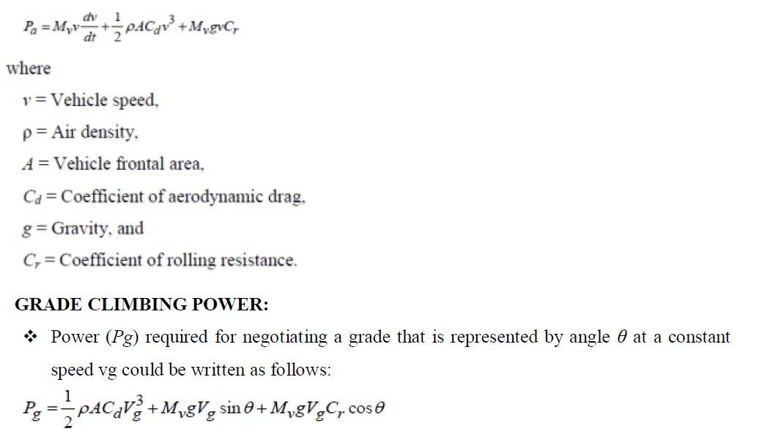

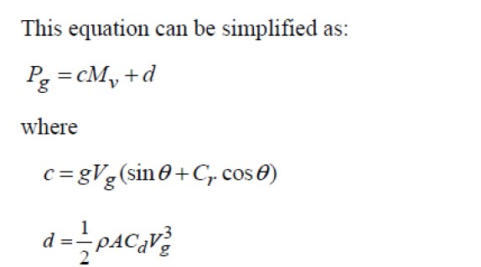

 The grade-climbing power requirement also has two parts, one linear to vehicle mass and the other a constant dependent on vehicle design. The term *c* represents the effects of grade specifications (i.e., speed and grade angle) and rolling resistance, while the term *d* represents the power required to overcome aerodynamic drag. 

 Both the acceleration and grade climbing power requirements are dependent on vehicle mass.  

**VEHICLE MASS:**

 A vehicle has three distinct mass groups: 

1. body,

2. chassis, and

3. drivetrain. The body and chassis for the hybrid and conventional vehicles would be nearly identical.

 Conventional steel vehicles have 73-74% of their total vehicle mass in body and chassis groups. The optimal use of ultra light steel might reduce the total vehicle mass by 10-12% while optimal use of aluminum would reduce the total mass by 31%. 

 In the case of a hybrid vehicle, a smaller power unit (PU), a motor and an inverter, a generator, a battery pack, and a gear-drive or transmission (depending upon the hybrid design) will replace the conventional engine and transmission. 

 The total inertia mass *Mv* is expressed as follows:

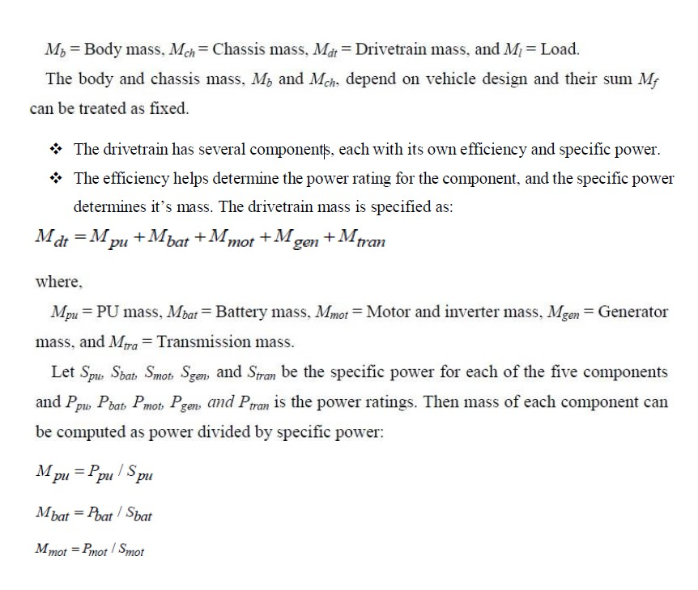

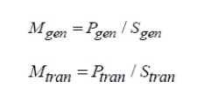

**COMPONENT SIZING:**

 The acceleration and grade-climbing power estimates from the above described procedure represent power delivered at the wheels. 

 Each component has its own power conversion efficiency and some losses are involved in mechanical components such as bearings. 

 A design factor, *k*, is used to account for other losses and contingencies. 

 The power rating of a drivetrain component depends upon the HEV system configuration, series or parallel. 

 The motor delivers all the required power through the transmission in a series HEV while both the power unit and motor deliver power through the transmission in a parallel HEV. 

 A series HEV’s transmission is simple, consisting of a few reduction gears, while a parallel HEV’s transmission is relatively complex, requiring linking of the two power sources. 

 Also, the power unit’s link to the drive axle requires greater control compared to the link of a motor. 

 The component sizing procedures are different for the two configurations with some assumptions common to both. 

 We assume that the power unit supplies the total power necessary for grade climbing in both the configurations. 

 The battery usually supplies the difference between the power required to accelerate from zero to 60 mph and that for grade climbing. 

The battery power would be higher if the HEV is required to have some all-electric travel capability unless much lower acceleration capability was acceptable for the all-electric vehicle operations

**MATCHING THE ELECTRIC MACHINE AND THE INTERNAL COMBUSTION ENGINE**

One of the most common matching elements used in hybrid electric passenger vehicles is the

**1. Epicyclic or Planetary - gear set.**

**2. CVT- Continuously variable transmissions (compression belt based) and**

**3. Toroidal Variator (variety)** are gaining popularity in compact vehicles and passenger vans because **of seamless transitions in ratio**. For larger CVTs the issues of torque rating and efficiency at high ratio continue to be developmental areas.

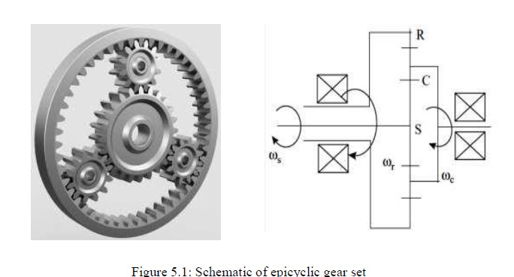

This is a three port mechanical component used as a speed summing device.

 Most designs rely on a dual input and single output where one input source is the ICE and the second input comes from an electric M/G.

 Epicyclic gear ports may be defined as input or output according to the convection illustrated in Table.

 The epicyclic basic ratio, k =Rring/Rsun where Rx is the radius of ring and sun gears (can also be defined in terms of number of gear teeth).

 The governing equation for an epicyclic gear in terms of the basic ratio and gear tooth number can be written as shown in: Ns + kNr − (k + 1)Nc = 0

 The relationship noted in table is used to explain the behavior of selected two ports when the third port is held grounded

This is the single input, single output case.

 When the third port is released the behavior is governed by table.

 According to Table 5.1 speed reversal occurs between sun and ring gear ports, and the speed at these ports is scaled by the basic ratio, k. All other input–output combinations preserve the direction of speed.

 The basic ratio, 1.5<k<4, is determined by gear diameters.

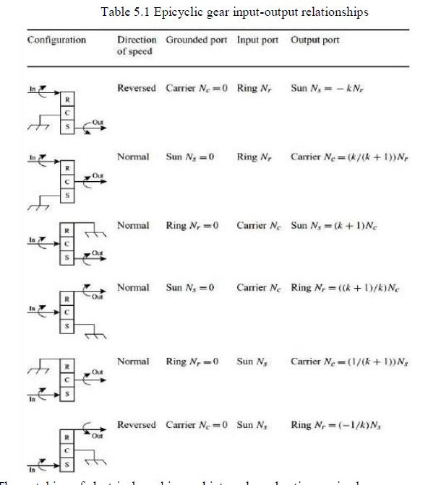

The matching of electrical machine and internal combustion engine have

1. Transmission selection and

2. Gear step selection.

3. Automatic transmission architectures have

Simpson type

b. Wilson type

c. Lepelletier type

d. Summary of transmission types

**1. Transmission Selection:** Passenger vehicle transmissions can be broadly grouped into manual shift, automatic and continuously variable. Manual shift transmissions (MT) have pre-defined step ratios that vary in a geometric progression. Modern MTs have an acceleration factor on the geometric ratio to realize smoother transitions and better drive quality.

**2. Gear step selection:** Transmission gear ratios follow a geometric progression that spans the desired range of speed ratio or shift ratio coverage. For example, a 4-speed gearbox may have a total speed ratio of 3.6:1 to 3.9:1, a 5-speed gearbox a ratio of 4.3:1 to 5.2:1 while a 6-speed gearbox will have a speed ratio of approximately 6:1.

**3. Automatic transmission architectures:** Prior to power split architectures, the most popular choice of transmission has been the automatic. The step ratio automatic transmission with torque converter remains the preferred transmission choice for crankshaft mounted and belt driven starter– alternator systems.

**a. Simpson type:** In the Simpson architecture a double planet epicycle gear set receives its input torque from the torque converter turbine at the inner planet and outputs its torque to the Simpson base transmission on the counter shaft via the second planet set. The transmission schematic, including torque converter with integral M/G rotor, is shown as Figure 5.1.

**b. Wilson type:** The Wilson stepped automatic transmission is simpler than the Simpson type because there is no counter shaft. The 5-speed Wilson type, however, requires three epicyclic gear sets, clutches and brakes along with an OWC (One way Clutch) Figure 5.2 is the schematic for a Wilson type automatic having an M/G for hybrid functionality mounted to the torque converter impeller as was the case for the Simpson type.

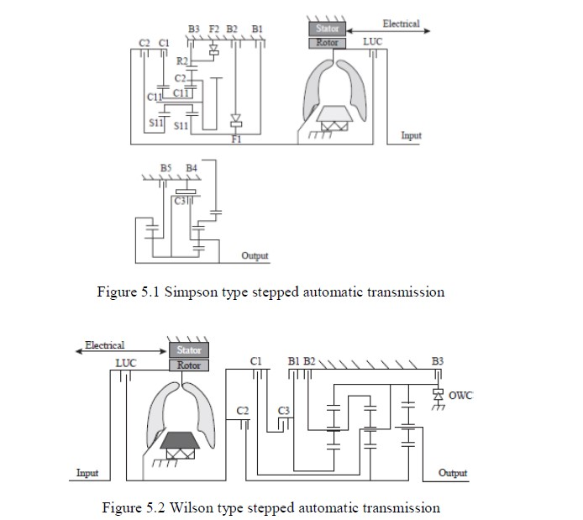

**c. Lepelletier type:** In 1990, a patent was filed by Lepelletier that described how to build a stepped ratio automatic transmission without OWCs. To realize this, a single planetary gear set and a compound or Ravigneaux planetary gear set are combined along with five shift elements. In the process, a 6-speed transmission evolved.

The Lepelletier transmission with hybrid M/G is shown schematically in Figure 5.3. Notice that, whereas the Simpson and Wilson type have the output shaft taken from the carrier of the output planetary set, in the Lepelletier the output shaft connects to the ring gear of the Ravigneaux set.

The key features of the Lepelletier transmission are input shaft to planetary ring gear with its sun gear blocked to chassis. The input planetary runs in all gears with the same ratio.

The feature of the single input planetary is the splitting of engine speed at the ring (true speed) and carrier (reduced engine speed).

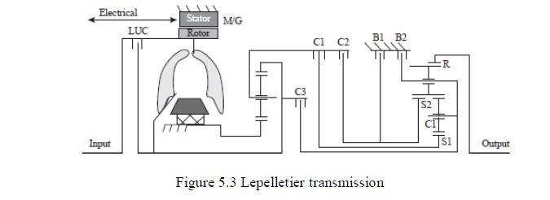

**Summary of transmission types:**

The three main types of stepped automatic transmissions differ mainly in the number of planetary gear sets, type of planetary gear sets, and the number of clutches, brakes, and OWCs required. Figure 5.4 illustrates the number and usage by transmission type.

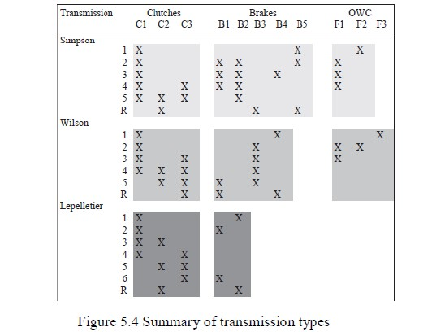

In Figure 5.4, the clutch, brake and OWC activation for each gear are listed. There are also brake activations in the Simpson and Wilson configurations for hybrid M/G braking (or coasting braking). These activations are not listed in Figure 5.4.

The key attributes of each transmission

type to point out are the number of supporting clutches and brakes necessary. The Lepelletier architecture is simpler and has less control activity than the other two types.

In the Wilson architecture the 1–2, 2–3 and 3–4 shifts are OWC shifts, and 4–5 is a clutch to clutch shift.

**SIZING OF PROPULSION MOTOR**

An EM is at the core of HEV drivetrains. The electric energy path of HEV consists of an energy storage unit (such as batteries, supercapacitors or fuel cells), a power processing unit (such as DC-AC converters) and an EM. In **Figure 5.5** a schematic of hybrid propulsion system is shown. Most EMs used in HEV or EV drivetrains have speed limit of 12000 rpm due to following reasons:

i. At very high rpm, the centrifugal force acting on the rotor increases and it is possible that the rotor might fail mechanically.

ii. The control algorithms of the EM involve determination of rotor position and this becomes very difficult at high rotor rpm.

The performance of EM is measured by following quantities:

i. Torque and Power Capability

ii. Constant Power Speed Ratio (CPSR)

iii. EM Sizing

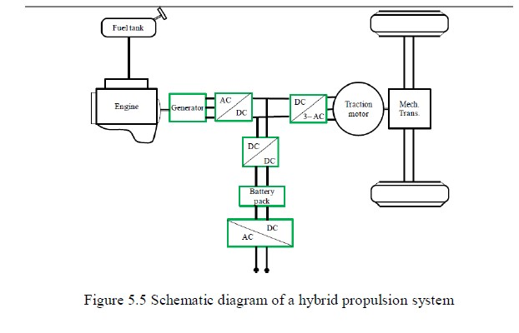

**PEAK TORQUE AND POWER:** The EM capability curves for torque and power define the peak operating capability curve of the HEV. In **Figure 5.6** a typical torque versus speed characteristics of an EM is shown. There are three curves shown in **Figure 5.6** namely:

i. ***Continuous rating***: The EM can be operated whin its continuous rated region.

ii. ***Intermittent overload operation***: The EM can operate in this regime for short duration (typically

<30s).

iii. ***Peak overload operation***: The EM can operate in this region for a very short duration (typically

<1~2s).

From **Figure 5.6 i**t can be seen that:

i. the peak output is about 2.5 times the continuous or rated output

ii. the intermittent output is about 1.5 times the continuous or rated output The various operating regions show in **Figure 5.6** is:

i. The region the flat torque region is known as the ***constant torque operating region***. In this region the DC-AC converter has sufficient voltage from the dc sources to inject required current into the EM.

ii. When the machine speed increases, the induced emf in the stator winding increases and the EM enters the constant power regime and flux weakening control is used.

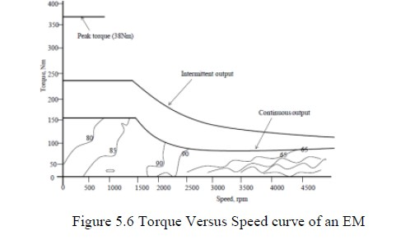

**CONSTANT POWER SPEED RATIO(CPSR):**

In **Figure 5.7** the operation of EM in different modes is shown. The description of various operation modes is as follows:

1. In the 1st quadrant the EM works as a motor and its direction of rotation is clockwise (CW).

2. In the 2nd quadrant, the EM operates as a generator and its direction of counter clockwise (CCW)

3. In 3rd quadrant the EM operates as motor and its direction of rotation is CCW

4. In the 4th quadrant the EM operates as a generator and its direction of rotation is CW

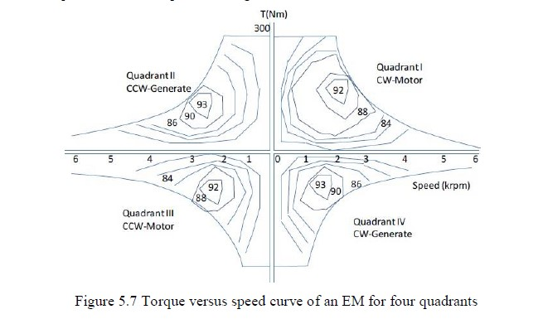

In **Figure 5.7** the efficiency contours for the EM are also shown. A few observations from **Figure**

**5.7** are:

i. The motoring operation of the EM occurs for positive torque and positive speed (CCW)

ii. For negative torque and negative speed (CW) the motoring action takes place.

EM SIZING:

The EM is physically sized by its torque specification. Since, EM torque is determined by the amount of flux the iron can carry and the amount of current the conductors can carry, and can be expressed as

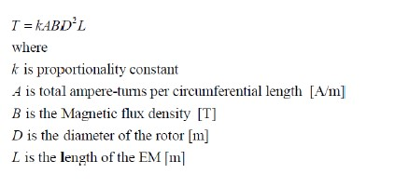

The two fundamental sizing constraints on the EM are:

i. Electric loading

ii. Magnetic loading

**SIZING OF POWER ELECTRONICS:**

 In **Figure 5.8** a schematic for the HEV drivetrain consisting of on board energy storage system, power processing unit and the EM is shown.

 The power electronics is an electrical element in much the same manner that a gearbox processes mechanical power to match the ICE to the road requirements.

 The power processing capability of power inverters is directly related to the dc input voltage available.

 Higher voltage means more throughput power for the same gauge wiring. The throughput power versus the voltage is shown in **Figure 5**.8.

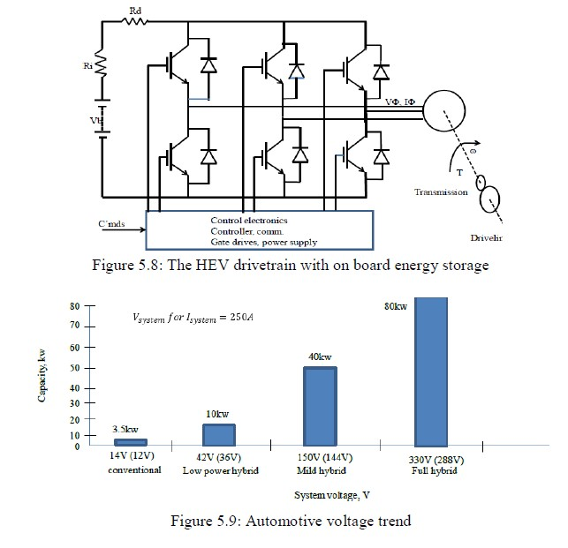

From **Figure 5.9** it can be seen that as automotive voltages move towards 42V, the sustainable power level will approach 10kW.

 For hybrid propulsion the **Figure 5.9** shows that voltages in excess of 150V are advisable.

 With recent advances in power electronic switches it is possible to move to voltage beyond 300V.

The Sizing of Power Electronics have other parameters are

1. Switch technology selection

2. KVA/KW and power factor

3. Ripple capacitor design

4. Switching frequency and PWM

**SWITCH TECHNOLOGY SELECTION:**

 Power electronic switching components are classified by process technology as originating from two layer, three layer or four layer designs.

 The semiconductor diode, for example, is a two layer planar device consisting of p-type and n-type doped silicon formed by a diffusion process.

 Two layer devices have a single p–n junction.

 Three layer planar devices include all the transistors in use today and have two junctions.

 Four layer, three junction, devices are categorized as thyristor

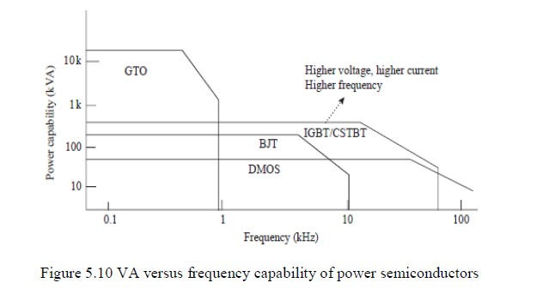

The volt–ampere capability of available power semiconductor switching devices is summarized in Figure 5.10 to contrast their power handling capability with switching frequency capability..

**KVA/KW AND POWER FACTOR:**

 In this section, the key aspects of power semiconductors will be introduced and the relationship of V–A apparent power based on device ratings versus real power throughput.

 Virtually all power electronic inverters for hybrid propulsion employ IGBT device technology.

 There has been some misconception regarding this technology, particularly in terms of what is a ‘motor-drive’ IGBT.

 Power semiconductor devices range in voltage withstand capability of from 3KW to 6.5 KW and current magnitudes of 3–4.5 kA.

 Thyristors have the highest kVA ratings, but are generally slow switching.

 The gate turn-off thyristor (GTO) is capable of switching 3 kA at 4.5 kV but is limited to less than 700 Hz.

 The emitter turn-off thyristor (ETO) is capable of simultaneously switching 4 kA at 4.5 kVA at relatively high frequency.

 IGBTs are making enormous progress in both voltage and current ratings, with some IGBT introductions being capable of 6.5 kV and 3.5 kA (not simultaneously), and high frequency versions are capable of processing kilowatts at switching speeds of up to 100 kHz (e.g. ultra-thin IGBTs).

**RIPPLE CAPACITOR DESIGN:**

 Power electronic inverters may have as much as 60% of their volume taken by the dc link capacitors needed for bypassing the load ripple currents.

 The dc bus capacitor is sized not so much for energy or hold-up time, but thermally by the rms ripple current it must circulate.

 First-principle understanding of inverters states that no energy storage occurs in the inverter, only switching elements.

 However, the high frequency currents generated by the inverter switching are sourced by the dc link capacitor, particularly if the battery is located far from the inverter.

**SELECTION OF ENERGY STORAGE TECHNOLOGY**

The Selection of Energy Storage Technology have used in the Electric Vehicles and Hybrid Electric Vehicles. They are

1. Lead acid Technology

2. NiMH battery

3. Lithium batteries

4. Metal air batteries

5. Fuel Cells

6. Super Capacitors

7. Fly Wheels

**FLY WHEELS:**

Flywheels are devices that are used for storing energy. A plane disc spinning about its axis would be an example of a simple flywheel. The kinetic energy of the spinning disc is released when the flywheel slows down. The energy can be captured by connecting an electrical generator directly to the disc as shown in **Figure 5.11**, power electronics being required to match the

generator output to a form where it can drive the vehicle motors.

The flywheel can be re- accelerated, acting as a regenerative brake. Alternatively the flywheel can be connected to the vehicle wheels via a gearbox and a clutch.

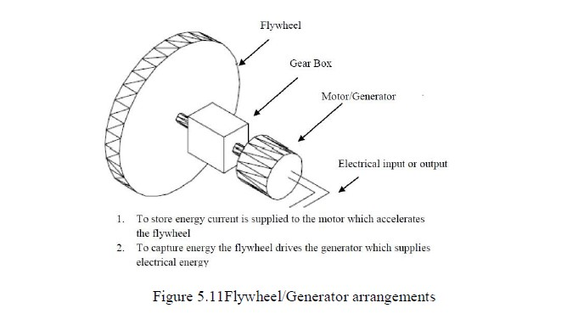

Whether mechanical or electrical, the system can also be used to recover kinetic energy when braking. The flywheel can be accelerated, turning the kinetic energy of the vehicle into stored kinetic energy in the flywheel, and acting as a highly efficient regenerative brake. The total amount of energy stored is given by the formula:

**D:\dept works\HEV\ehv latest notes screen shots\Screenshot 2022-12-01 120352.jpg**

where *E* is the energy in joules, *I* is the moment of inertia and *ω* is the rotational speed in radians per second. When a flywheel reduces from *ω*1 to *ω*2 rad s−1 the energy released will be given by the

formula:



**SUPER CAPACITORS:**

Capacitors are devices in which two conducting plates are separated by an insulator. An example is shown in **Figure 5.12**. A DC voltage is connected across the capacitor, one plate being positive the other negative. The opposite charges on the plates attract and hence store energy. The charge *Q* stored in a capacitor of capacitance *C* Farads at a voltage of *V* Volts is given by the equation:

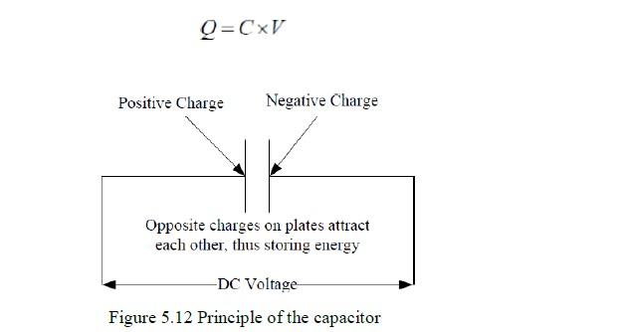

As with flywheels, capacitors can provide large energy storage, although they are more normally used in small sizes as components in electronic circuits. The large energy storing capacitors with large plate areas have come to be called super capacitors. The energy stored in a capacitor is given

by the equation:



where *E* is the energy stored in Joules. The capacitance *C* of a capacitor in Farads will be given by the equation:



where *ε* is the is the permittivity of the material between the plates, *A* is the plate area and *d* is the separation of the plates. The key to modern super capacitors is that the separation of the plates is so small. The capacitance arises from the formation on the electrode surface of a layer of electrolytic ions (the double layer).

They have high surface areas, e.g. 10, 00, 000 m2kg−1, and a 4, 000 *F* capacitor can be fitted into a container the size of a beer can. However, the problem with this technology is that the voltage across the capacitor can only be very low, between 1 V to 3 V. The problem with this is clear from Eq. 4; it severely limits the energy that can be stored. In order to store charge at a reasonable voltage many capacitors have to be connected in series. This not only adds cost, it brings other problems too.

If two capacitors *C*1 and *C*2 are connected in series then it is well known1 that the combined capacitance *C* is given by the formula:

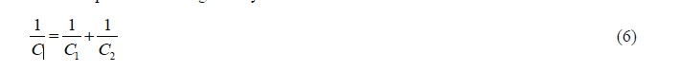

So, for example, two 3 *F* capacitors in series will have a combined capacitance of 1.5 *F*. Putting capacitors in series *reduces* the capacitance. Now, the energy stored increases as the voltage *squared*, so it does result in more energy stored, but not as much as might be hoped from a simple consideration of **equation 5**. Another major problem with putting capacitors in series is that of charge equalization. In a string of capacitors in series the charge on each one should be the same, as the same current flows through the series circuit. However, the problem is that there will be a certain amount of self-discharge in each one, due to the fact that the insulation between the plates of the capacitors will not be perfect. Obviously, this self-discharge will not be equal in all the capacitors; life is not like that! The problem then is that there may be a relative charge build-up on some of the capacitors, and this will result in a higher voltage on those capacitors. It is certain that unless something is done about this, the voltage on some of the capacitors will exceed the maximum of 3 V, irrevocably damaging the capacitor. This problem of voltage difference will also be exacerbated by the fact that the capacitance of the capacitors will vary slightly, and this will affect the voltage. From Eq. 3 can see that capacitors with the same charge and different capacitances will have different voltages. The only solution to this, and it is essential in systems of more than about six capacitors in series, is to have *charge equalization circuits*. These are circuits connected to each pair of capacitors that continually monitor the voltage across adjacent capacitors, and move charge from one to the other in order to make sure that the voltage across the capacitors is the same.

**SIZING OF DRIVE SYSTEM:**

 The major components in a hybrid drive train include traction motor, engine/generator, and PPS (peaking power source).

 The design of the power ratings of these components is the first and most important step in the whole system design.

 In the design of these parameters, some design constraints must be considered, which include

1. Acceleration performance

2. Highway driving and urban driving, and

3. Energy balance in the PPS